**These are the notes referred to on the following official copy**

Title Number MX352605

The electronic official copy of the document follows this message. This copy may not be the same size as the original.

Please note that the quality of one or more pages may be poor. Unfortunately this is the best quality image we hold of the document. If you are able to obtain a better quality copy from another source we would be grateful if you would send it to us so we may update our records. Alternatively if you know who holds or may hold either a copy or the original please let us know so that we may contact that person.

Costs or expenses reasonably incurred as a result of the mistake may be recoverable as indemnity under paragraph 3 of Schedule 8, Land Registration Act 2002. However the Registrar's consent should normally be obtained before such costs are incurred. If you intend to incur costs as a result of any loss arising from the poor quality and to claim for these under the statutory compensation scheme please inform us of the steps you intend to take, what is the estimated cost and how this has been calculated. Our *Practice Guide 39 - Rectification and indemnity* contains further information. We appreciate that the payment of indemnity will be an inferior alternative to a better copy of the document itself.

You can view or download copies of the practice guide from our website at [www.gov.uk/land-registry](http://www.gov.uk/land-registry) in English or Welsh. Alternatively, you can telephone Customer Support on 0300 006 0411 (0300 006 0422 for a Welsh-speaking service).

Please note that this is the only official copy we will issue. We will not issue a paper official copy.

' ►

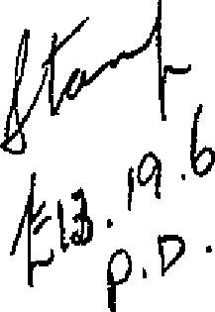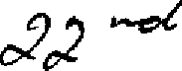THI:3 LEASE ma<'le the

One thnusand nine hundred ann fifty >7

dayof

B E T *'\,\T* E E N

;A17IS CCNTRJICTOllS r.nrr }hose registereil o ice is situate at LI52 Kilburn Bigh "Road in the Ooun ty of London_,',(hereinafter called

11 the Lessor11 w'r>ich expression sha11 where the con text so perrni ts include the persons for the time being entitled to the reversion

immediately e:xpectant on the determination of the term hereby

.:-,.,.

area tea) of the first. part 2ee.:.,..._ L {

. liS .:hl- *P ;>* ...,.,;.._ *L* N *w.*

w7

•.•

'

*if.'"=-*

(hereinafter called "tbe Tessee" which expression shall where the

context so permits include the persQns deriving title under the Lessee) of the second part and'FLfiTS *lJ.T.l* EST.ATES. Hf,!T.i GEMENT LD.O:T.ED

*:..-*

",

-. hose registered office is si tl.Jate at :-5"_, Vic,tc;rfa. Street .ih the

. . '>

<;i ty of Westminster S.W. l '. (he reihafter called II the Company11) of the thil"ci part

N O W THIS LEASE nwae in consic1era tion of the sum of TWO

TJ-IOUS.llJ\1T:l FIVE h"'TTNDfilm lND FIF'TY POOFDS ,paid by the Lessee tu the T,essor ( the receipt whereof the Lessor hereby ackni::•wledges) and of the yearly l'ent and covenants on the part of the Lessee hereinafter reserved and contained

WITNESS ETH as f llows:-

1. THE Lessor HE BY' DEMISES unto the Lessee .ALL TFliT Flat

landing

(t!:);lt:fhl:}Th.G e-.:mft.:i,,)Jt ana sdY.ad:.'!XC'liKOO described in Part I cf tbe Scbedule

hereto (hereinafter together called "the Flat") • TCGE'rlIE'R W:!:IB :..

the rights privileges and appurtenances sat out in Part II of the Schenule hereto EXCEPT AND RESRRVING to the Lessnr tbe rights set out in Part IJI of tbe Schedule her tr.,

Term TO HOLD the same un t0 the J",essee frnrn the•25th day of Mercn' 1957

=

Rent TIELDil'TG .l'iND P.A".JN therefor during the said term the yearly

. '



# LESSEE'S

COVENANTS

To pay rent

Tr:i pay rates

anr.l taxes

To repair>

Exterior painting

Interior

### painting

rent of[TEN' P® payablc byf'nur equal instalments in advance on the usut'll qllartcr days in eech ana every year free of any aeauction whatsoever except the Landlords Property IJ.'ax The first such payment or a proportionate part thereof to be made on the exeolltion hereof

1. THE I SSEF.: ITTREBY COJENANTS with the Lessor as follows:-
   1. To pay the rent hereby reserved f'. t the time end in manner aforesaid withC>ut any c1eduction except as aforesaid

. (2) To pay and discharge cill rates taxes duties assessments charges and outgoin s whatsoever whether Parliamentary parochial or of any other description which now @.'re or during the term

hereby gran tea shall be impr,sed or charged on the Flat er any part thereof or the Lessor or the Lessee or the nwner or occupier in respect thf:reof ( the I,and1ords ?roperty 'l'ax only excepted)

1. From time tn time ana at all times during the said te m

well and sub_stantially tc, repair uphold support clean maintain ara in and keep the Flat fd,,m0l §l.:km,-g'Xtrllt!.Xx l11.::!m "l::t \il.-xh:r:t:lrlxi<brfie:):('. §).;fuchl;tt

### and also to the landing thereof, na all

H & the staircase leaoing f J&! !xx tR lltitrlt 3cl. t ·

aaditions which may at any time during the said term be made to the Fl8 t and the fixtures therein f1ND jcintly with. the- Lessee or

Lessees for the time being of other flats entitled to use the same tn repair maintain ana keep the party v,alls hatched black on the

### Plan annexed hereto

1. In the year One thousand nine hundred and sixty and thereafter once in every third year and in the last yeer of the said term whenever ann however determined tc, paint in a colour

tf") be approved by the I,essor' s surveyor for the time being all the nutsiae wood and ironwork of the Flat and all additions thereto with two coats at least *of* good oil and white lead

paint in a proper and workman- like manner

1. Once in evF-ry seventh year and in· the last year of the

### 2

' ,

said term whenever ana however determined to paint all the

and also

interior of the Flatx6©roboor:it'bihe!'ti the said staircasqc) and all

additirms thereto usual or proper to be painted with two coats

at least of gr.nd oil and white lead paint in a proper and workman­ like marner and also at such times as last afnresaid to whitewash

and the said staircase c11lour and paper such portion 0f the interior *of* the Flay as are

Joint liebili ty for, hall

To yiela Up. in repair

Inspection by Lessor

usually so treated.

1. Proviaea. Blways and it is hereby declared that the

liability of the Lessee unaer the covenants contained in sub­

clauses (5) (4) 0nd (5) hereof shall so fAr as relates tc· the

landing and edged red . end the staircase leadfn,g_ thereto Jen-t:>m a b i colourea yelrmf on the plarjbe a liability jointJ.y.

with the lessee for the time being of the adjoining Flat Number'.m8t in the Building and shall S() far s relates as aforesaid be enforceable as if such covenants had been entered into by the Lessee jointly ""1. th such other lessee

1. To yield up the Flat at the expiry or sooner determination

of the said term in such state of repair deco ation and cohdition

f.

'

as\accoras with the covehants hereinbeforo contained together with

,/

all additions ana improvements mane thereto in the meantime and all fixtures of every kind in or upon the Flat or which duFlng the said term TILqy be affixed or fastened to or upon the same (except tenants ._fixtures)

1. To permit the Lessor and itss.lrveyor or agent with or without workmen or others at all reasonable times during the said term to enter into and upon the Flat or any part.thereof

i t x±bta:N:xt:b:&:xs:irockwa:s = to view the condition thereof and also effectually and substantially to make good and restore all defects and wants of reparation which shall be disouvered on any such examination and of which notice in writing shall be given by the

I,essor to the T,essee within one calendar month after the giving of such no ticc

'Repair by Lessor

En ry by adjoining Lessees

Insurance

Premium

#### Pot to assign

etc, f:Brt- only

1. To permit the -r ossor if the T,essoe shall make default in

any of the covenants hercinbefot'e cor.tained for nr relating to

### or of the said staircase

the repair of the ·F1la *y* (but without prejuclice to the right of

and sta il'case

re-entry hereinafter contained) to enter upon the Platjand repair

the same at the expense of the I-essee in accordance with the covenants and provisions of these presents and the expenses of

such repairs or in the case of repa\rs for which the I-essee is

liable jointly with another or others _the appropriate proportion of such expenses to be determined by the I,essor' s surveyor shall be repa ia by the :·.essee to the :r,essor on demand

('.LO) To r.ermit the Lessor and the tenants of the adjoir.ing

#### . . . 4 8 5

flats numbed .72 l5 and % and their respective agents or workmen at

any time or times during the said term but only (save in Cflse of

urgency) at .reasonable hnurs and upon giving reasonable notice t0 enter upon the "Flat so far as may be necessary for executing rep·airs or alterations flf or upon such aajoining premises or for

constructing laying aovm altering .r pairing cleansing emptying or maintaining any sewers watero0urses cesspools gutters drains waterpipes electric wires or gas pi-pes in connection with or for

the accommoaation of the said adjoining flats causin as li t_tle damage or aisturbance as may be to the Flat and restoring the same and the sl.lrfe.ce of the soil and /everything erected thereon to its former condition without any unreasonable delay but without making any compensation for any temporary damage or inconvenience

1. Not to do or suffer anything which will or may make void or voidable any policy for. the insurance against fire of the

Flat .or of any adj"oining flat or which causes an increased premium t be payable for s ch insurance

1. Not to assign charge underlet or part w:L th possession

of part only of the Flat or permit or suffer-·any person to

\'To 1!'egister

## as:fiigp.men ts

etc.

## Not to assign or transfer the demised premises except to an assignee who shall oon·temporaneo1isly with such assignment or transfer enter into-covenants w.ith the Lessor and the Company in a form to b approved by the solicitors for the time being of the Lessor to observe and perform the covenants contained in Clause 3 hereof' and wi.thin twenty one days after the date of any assignment underlease or other devolution. of .the demised premises at his own cost to deliver to the Lessor's solicitors fQr the time being an

abstraot from suoh assignment underlease or other document contain­ ing the date thereof the names and descriptions of the parties thereto and speoifying the party or parties in whom the or any legal estate is thereby vested and will at any time pay to suoh Solicitors a fee of one guinea in respect of every such dealing

* I, )

***f***

To register assignments etc.

assign charge unaerlct or pert with possession of part only of

the T<'la t

**(-1:3)** 1!/4:t-b.4-r-1-'bwen *ty* Dne days af"te:r"the <le. te of' any assignmen

**hi72:•**

### unaerleaae or other devolution of the Flat at

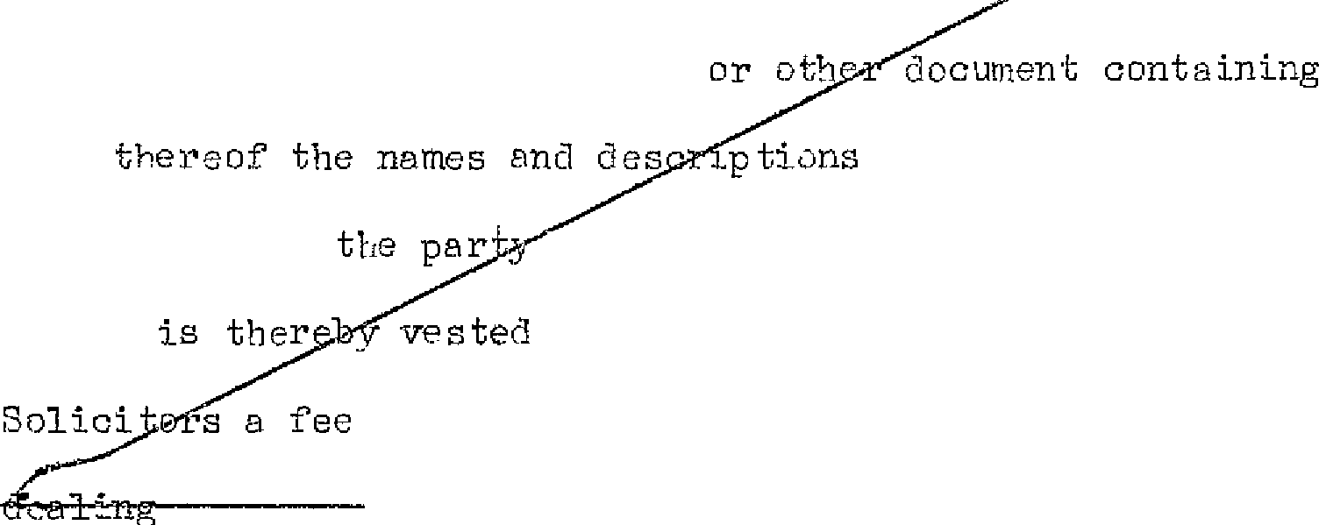deliver to the Les.;or' 3 Sol i cito:s for the eing an abstract

from sue, assignment una erlease

#### aate

and specifying

### estate

of the parties thereto or parties in whom the or any legal ana will at the same time pay to its

of Twenty one shillihp:s in respect of every sL:wh

Use only as (14) To use ana occupy th8 Flat as a private dwellinghoUs6 **in**

one dwelling-

bouse- one single **or** family occupation only and not for any other purpose

Not **to**

conttavene

1. Not to do or omit or permit to be done or omitted anything

Town Planning in the Flat the aoihg 0r omission of which shall bo a contravention lwts

### Not to cut

maim or injure

!Tot to make alterations

To insure

of the Tovrr1 & Calm try Planning .Act 1947 a,1a to inoemnify the I,essor against all actions proceedings damages penal ti s costs charges clBims and demanas in respect of such acts or omissions

1. Not to cut maim or injure any of th0 principal timbers roofs or walls of the Flat nor erect or suffer to be·erec c any new buildings thereon or·make any structural alteration or addition-· to the Flat
2. Not to erect upon any part of the Flat ary building

whether temporary or permanent other than the Flat hereby demised and not withollt the previous licence in writing of the Lessor or its surveyor for the time being to make any alteration in the plan or eleva ti [ill offthe said F·la t or in any of tbe party vra11s

or in any of the principal or bearing walls floors or timbers

1. l!t all tirr.e s during the term hereby granted to insure

and keep insurea tbe demised premises under a householders

comprehensive;

#### policy for private awellin s (all items with no

5

#### exclusio s) to be issued in the joint names cf the Lessor and the

Lessee by the '3un Insurance Office of 307 Finchley Roed in the

L **United**

County of London or such other ins1Jrance office in the

#### Kingdom

as may from tirne to time be nominated by the Lessor in the

IT' --

sum of :,,£2550• or ::;uch other sum as the Lessor shall from time to

:;_.

#### time declare to be equal to the full valiJe thereof (including professional fees incurred in reinst tement) and to pay all premiums necessary for tbat purpose within seven days after the same shall become due and whenever required to produce to the Lessor the policy of such insurance anq in case of any damage or destruction

to the demised premises forthwith to lay out the insurance money in rebuilning or making gooa the damage sustainea in eccordance with any statutory or local enactments for the time being in force anrl to make up any deficiency out of his own money PROVID:1'.:D J,LY'fl.YS that if the demised premises shall not be kept insured as aforesaid the Lessor may insure the same and pny the premiums and the amounts tbereof shall be repaid by the Lessee forthwith and until payment thereof shall be recoverable by distress as for rent in arrear

To pay Gas (19) To pay all charges for gas md electricity supplied to the and Electri-

city Flat as shown by separate meters affixed therein and the chBrges

for such meter3 ana to 5-ndemnify the I.,essor :i.n r8spect thereof

To observe 1{egulations

To pay costs of Section

146 Notice

1. To observe ana perform the regulations set out in Part IV of the Schedule hereto and such other reasonable regul.?.tions which the Iessor may from time to time make for the proper r-wm1gement

as a high-ala ss residential b!lilding of the building of which the Flat forms part

#### To pay to the Lessor all expenses (including Solicitors' costs and Surveyors' fees) incurred by the Lessor incidental to the preparation and service of a notice under Section 146 of the Law of' Property lict 1925 notwithstanding that :rorfeiture is avoided otherwise than by relief granted by the Court

X and in in ur in3 in the joint names o:f' the Le ci sor and Company against Third Patty claims made against them or .84 either oi' them in respect of the lawns, gardens, footpaths and cer iageway

Lessee's covenant as to garden

#### e to.

Company1 s CF')Venant as to garden

#### etc,

LESSOR'S

* COVENANTS

### Quiet

enjoyment

"Repair ana Insurance of ad_ oining premises

1. . TEE LESSEE HEREBY COilEN.f..HTS with the Lessor and as a separate

in the year 1957 the sum of ,ClO and

### covenant with the Oompany to pay to the Company/in each

**succeeding year a**

### /sum equal to one twelfth of the aggregate of FIRST all expenditure

reasonably ana properly incurred by the Company during the previous calenrtar year in performing the covenants on the part of

X

the Company set forth in the succeeding clause hereof/and SECOND

an amount equal to Ten per cent of such expenditure such amount being payable to the Company as a management fee such sum to be pa id to the Company wi tbin one month after a aema nd in writing

therefor has been left at or sent by post to the Flat addressed to

### 11the Lesseett thereof

1. THE r,OMPJ,NY HEREBY COVENANTS with the Lessee th0t the Lessee duly pa_ying to the Gompany tbe rnr>neys payable under the last fore­ going clause hereof the Company at all times during the term hereby

granted will maintain ana keep in good orner repair and condition

**d.k.k**

as a laVl/11 or garden the land coloured green on thejPlan and will

repair maintain and clean the footpaths and the carriageway

coloured yellow on the plan

1. TiiE LESSO HE11EB'Y CO\i'ENL!ZTS with the Lessee as follows:_-
   1. That the Lessee paying the said yearly rent hereby reserved and observing and performing the covenants and con itions on the part of tbe I,essee herein contained shall and may peaceably and quietly possess and enjoy the rlemised premises during the term hereby granted with0ut any lawful interruption or disturbance by the Lessor or any person claiming under the Lessor

### That the Lessor will not during the term hereby granted

below

### grant any lease or tenancy of the premises immediately a the

Flat and known as 5 save UflOn terms that the lessee or tenant trereof 00·1.renants for the repair of the saiC'1 Flat No, *1l* 5

Flat N0. *-0*

below

(including everything, hDMe the level of the underside of the

hich forms the floor of the flet hereby demised c onere te f'l oor/ ,l'ltx:moor-r..flt'axb-..'1No,;r...ln0em"t!{J'i "6' lim.ffi :lfilfiC ri wc

*I'*

t;bS{J:01mdltxths:n n:e9 in the like terms as are set OLE in Clause 2. (3)

hereof and to insure the said Flat No. i j_n the: like terms as are

set our in Clause 2, (18) hereof PROI.TIDED *l>.UlJ;YS* and it is hereby agreed that in the event nf the assignment by the Lessor of the reversion imneaiately expectant upon the determination of the term

hPreby granted the Lessor shall on and from the date *of* such assignment cease to be liable in respect of any breach or.breaches

of this covenant which

To perm hflt thLessee Company to

may occur after the date of such assignment

duly paying the monies payable under dlause

enter garden etc.

Proviso for

### re-entry

·Service of Notices

3 hereof ·l;he Lessor will permit the Company its and agents to have access to the land colnured yellow on the[plan for the purpose of performing the covenant on the part of the Compsny

contained in r.lause 4 hereof

1. PRO\TIDED 1\LW.A'"S that if the saio yearly rent hereby reserved or any part thereof shall at any time be unpaid for twenty one days after the same shalJ. have become clue whether the same shall have been legally demanded er not or in case of the breach non­ performance or min-observance of any_ of the covenants on the part

of the Lessee herein containe:I then ana in any su·ch 9ase it shall '} be lawful for the Lessor or any person authorised by it to enter

into and upon the demised premises or any part thereof in tbe name of the whole and to repossess the same as of its formf:)r estate and thereupon the term hereby crca tea shall absolutely determine but without prejudice t0 any right nf action or remedy of the Lessor

/

in respect of any breach of any of the covenants by the Lessee *I*

·'

hereinbefore contained

1. IT IS }illREBY GREED that any notice hereby required or authorised to be given rto the Lessor or the Lessee shall be in writing and may be given in manner provided by Section 196 of' the Law of Property Act' 1925 with respect *to* notices to be given to a lessor or lessee trnder that .Act

8

SCII'.EDULE



#### *AU* Tltri.$! Flat known or to be lmown as,, No. on the fil"st floor

. r

7

* t,.-

of Langham Oourt Station .Approach South Ru1slip in the County of "=? *v,_* . •.

Utddlesex /as the said Flat ls shoWbJ6n th& Plan f!nnexed hs.tieto

## TOGJ,J.i:WI? tJITn: the **first** floor landing coloured yellow and 'edged

red on the- sata plan and adjoining the ssid Flat whi<,h aaid Plat and. londlng shall be deemed to inelud.e •the .concrete tloOl! foming the first fioo't' ¢f the building but not· the oeiling plasteY.' affixed to the underside of suoh :floo:I! and eve:cything above the level of· the

. under ide of such floor· and. in partioulai- so mu.ch of the oof of

# the building as s v tically above the- s td flat end l ttdzng sud to include also

## so .much of any pipe gutter. or othar. thing off i ed to th out. icle of the said Flat 1:.lnd lending bs is e'bove the said level.

Cons trllo tion

### Marginal Notes

Certificate

as to value

B. IT IS HEREBY GREED that in this lease references to any bet or nets of Parliament shall be construea as including references to any statutory modific!:l.tion or re-enao-tment thereof for the time be1.ng in f'orce

1. TP.E marginal notes shall be deemed not to form part of these presents and shall not be taken irito account in the construction or interpretation of Any covenant condition or prDviso herein contained
2. IT I8 HF,P..EBY CEP..TIFIBD that the transacticn hereby effected aoes not form part of a larger transaction or of a series of transactions in respect of which the amount or vallle or the

aggregate amount or vallle.of the consideration other than the rent exceeds  pounds

I N W I T N E S S wh reof' the Lessor and the Company

have hereunto affixed their Common Seals and the Lessee bas hereunto set his hana and seal the day anc'\ year first before written

SC HE D. U .LE

P.IIRT I

.,

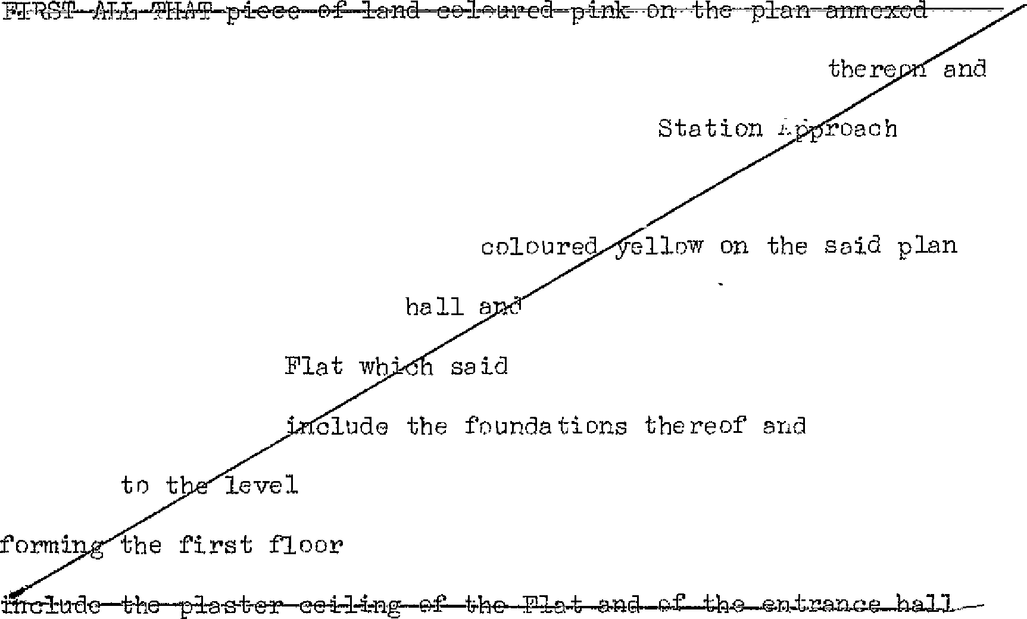

hereto together with the Flat erected or to be erected

known or to be knriwn as No. 5 Langham Court

South

Ruislip in the County of M:iddlesex MID

SECONDLY fJJL THJ:T piece of land together with the entrance adjoining the said

shall be deemed to

staircase erected thereon and Flat entrance hall and staircase

extend

upwards

of the underside of the concrete floor

of the building and shall be deemed to

9

affixed to such concrete floor and to include also SD much of any pipe ana/or otber thing affixed to the utside cf the said Flat and entrance hall as is below the said level

Rights included in demise

#### Easements of .Access



. asements

of Water eto.

. Support and Protection

Lawns and

*(',.a* rdens

#### Access to adjoining­ Flat

Benefit of

#### 1iep:ula tions

S C Il E D U I, E Pf.R'l' II

* 1. The right in common with the Lesser and the lessees or occupiers for the time being of the other Ji'J.a ts in the Building ancl all others

having the like right to use for purposes of acr:ess to and egress

first

f'rom the Flat/the se v na paths col0ured yeJ.low on the

and secon!ihe/sta ircase leading from the ground floor to said plan/JLaj;!:Jj]{_ _tx]LOW M..§l:RiiI SX:l\:mzx:tJ:t ft±mt:xwa-in:Jmnmrer::

:;!.l i rikn ft:fx. 11l Jdt} :i:i: *.ea* A,,

g s;gr1.1·i0& reed t:,na pd hhs hE-¥C;t. :f:.G:i;,e eonteillcd

* 1. The ri gbt in commori with all oth2rE for the time being having

the like right of passage and running of gas electricity water

Rnd soil from an11. to the Flat tbrr,ugh the pipes wires conduits and

drains in under or- upon the Building

5. All such rights of suppc1rt 8 na protection as are enjoyed by the

Flat from the other flats adjoining the same at the dAte hereof

4. The right to use in common with the Lessor end the lessees or occupiers for thc- time being of other flRts in the DoildiI'-g and their visitors thP. la1Jll!ls and garaens coloured green on the plan

subject to such reasonable rules and regulations for the common enjoyment thereof' as the Lessor may from time to time prescribe

. 5. The ri.ght ( to be exercised save in Et case of urgency only at reasonable times ancl upon being given reasonable notice) to

enter uprn tbe premises adjoining the Flat and in particulr:,r upon the flat !rnoYm. as ].'Jo. ) f0r the purp0sc only of executing any necessary repairs and alterations to the demised p!'emises the

Te_ see causing as little damage disturbance and inconvenience

: '

s phssibl.e ana making gorxl a11 damage occe sioned thereby but . witrfo:iut~making any compensation for any temporary damage or inconventence.

6. The benefit (in so far as the Lessor can grant th same) n

### 10

-

This official copy is incomplete without the preceding notes page.

#### corrnnon with the Lessor and other persons enti tlca thereto of any covenant or agreement enterea into by a lessee of any other flat in the Building with the Lessor f'or the observance and performance of the regula tfons specified in the S::heaule hereto

SCHEDULE

FLIRT III

#### ""Right to pass along T;;ntrance Hall and Staircase

Support ana

ProtecUon

Passage of

Water etc.

EXCEPTIONS / TD RESERVATICNS



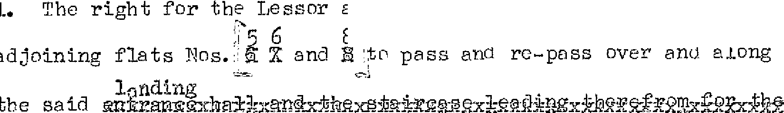

and the·lessees and occupiP.rs of the

s""S:\

#### Such rights of support and protection to the flats adjoining the Flat as are now enjoyed from the Flat

1. The free ana uninterrupted passage ana running of W3ter and soil gas and electricity from and tn the other flats in the Builaing thr••Ugh the pipes wires conduits and arains in under or upon the Flat

Access for 4. The right for the Lessor t1,.n,,,c., l the lessees and occupiers of the

Lessees aajoining nats osTi and Xitr enter upon the Plat or any part

adjoining 8."

L...

#### thereof(but only ±save in case of urgency : at reasC\nable times and upon giving reasonable notice)for any of the purposes and subject to the provisions mentioned in Clause 5 of Part II of this Schedule

Rights of Light

5. The right for the Lessor at any time hereafter to build or

,.

..

#### rebuiln ,:in ,my adjoining or neighbnuring landjaccording to such plans (whether as to height extent or otherwise) and in such msnner 8S the J,essor shall think fit notwithstanding any inter­ ference thereby occasioned to the access of' light to the Ji'lat

11

#### X ( othez- than the land coloured gl'een and yellow on theflan)

. .

..! \

.. '

SCHEDULE

?f..RT IV

#### Nothing shall

REGULLTI ONS

1. :Nioxtx::b::ric.illornxx r.md:ltc ncr emcm.{ be done upon the Flat or any part thereof :mcyx x t:c:on)hbbmg which sball or may be or become a nuisance damage annoyance i)r inconvenience to the Lessor or to the lessee 0r occupier for the time being of any adjoining or neigh­ bouring flat or to the neighb0urhood
2. No person of unsound mind or *of* drunken or immornl habits shall be permitted to reside in the Flat
3. No windows or lights belonging to tho Flat or tho Building of which the Flat f'orms p2,rt shall be stopped up darkened or obstructed
4. No music or singing whether by instruments voices wireless gramophone television or other means shall be allowed in the Flat or the Building between 11 p, m. and 7 a. in.
5. Nothing shall be aepositea or left in the entrance hall stairways or passages of the Building neither shall any carpot mat or rug be beaten or children allowe<l to play tbcrein neither shall the same be in any way obstructea
6. o person shall :reside in tre Flat unless the floor thereof (including the passages) are oovered with linoleum carpet r1<1gs

or other-suitable materisls except while the same shall be removed f'or cleaning repairing or decorating the lat or for some temporary purpose (This "Regula tic:in however not tr) apply to a gr0und floor flat)

1. No flower pots or other things shell be placed outside the

windows of the Flat unles.s securol:T f'astened to the windcw boxes **provided**

to tre satisfaction of tbe Lessor

1. Not to use or permit or suffer to be used the land coloured

green on the plan otherwise than as a lawn or garden and not to

,.

..

..;

.l~o- '

0

do or permit or suffer to be done thereon anything which would

be a nuisance or inconvenience or clisturbance t'J an:r other person

using the sarre

* 1. *No* advertisement or notice of any description shall be placed on the outside of any of the walls r,r ,Joors of the Flat or the Building except tbat the name of the Lessee (w:i. thou t eny notice of the profession or business of the Lessee) may be painted or

affixed outside the entrance door of the :IT'lat in such style as the Lessor sha11 approve

* 1. Not to leave or park any motor or other vehicle in the

carriageway aajoining the rear l:'f the Building so 'JS tr, cause

annoyance or inconvenience

any flat in the Building.

the essot' or

#### o any, essee or

t

occup1.e1• of

*e*

I

*J*

# No• ll

## *N k* tn fix a Wireless or television aerial to the exterior of the

·? d flat or building but shall be entitled to use such

satevision aerial as the Lessors may erect on the roof of the

## 3 !:ia building, the position of such aerial to be at the absolute

discretion of the Lessor0



#### 13

•. .1-,

195

DAVIS CONTB.i,CTORS LilVIITED

and

FLATS & ESTl,TES M.ANitGEMENT LIMITED

to

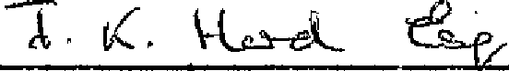

*:):*

-*J*-*c*

* o l •

.,..

•. *'r*

LEJ.,SE

of

Flat N0,7::fi, Langham Ci'.,ur·G, Stat ion Approach, South Ru isl ip in thE. C r-m.;-ty

* + of Middlesex



Term: 99 years

Fro:n: aay of

Rent:' £10-0-0 per annum

195

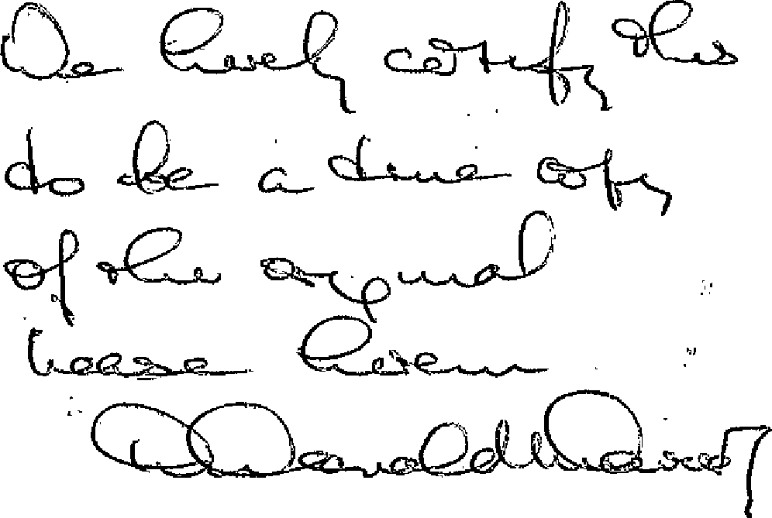

1. Donald L. Tuvies & Co.,
   * 195 Ealing ?..c,aa,

l,lperton,

Wembley,

IV!;ir]d le sex,

'\

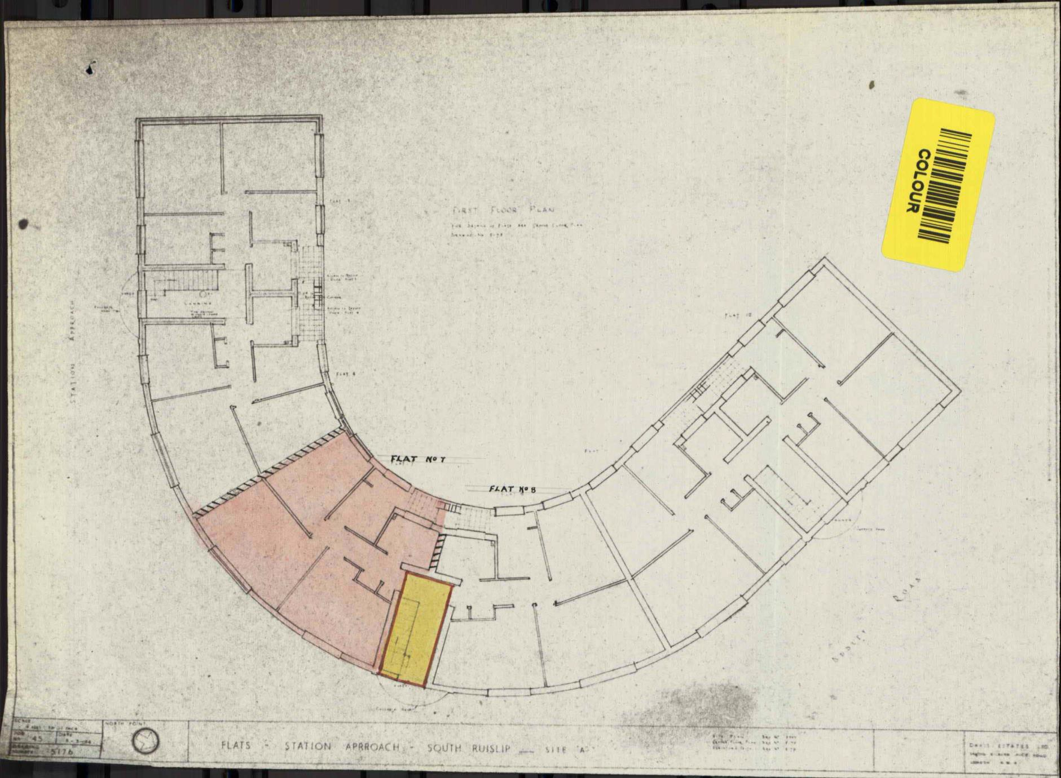

|  |  |  |
| --- | --- | --- |
| \  \  r-,--,-T--,--  1 I I t I  L-------.- -r----;--- JI · E **S C *E N*** .,.  r----  1 I •  I  I r.: --- --  0 I  **z**  ***w***  .... I  6 7 **2 3: 4 5 8 9**  (/) I **PUBLIC**  I  1-:-:7-----t J---'--------; 1 _-  **. ----1-nL }- =:::::r:T ..:**  **S RVICE** 1 **ROAD** /  ,_ - - - --------+- . -------+-- - - - )  -· 0---- - - - -+---'-0-- - - ------  0-------------------r;-- ----  ----------= -**ST**-**A**-**TION APPROACH**  =-=====-===  *I* ,.  I | | |
| **SCALE** |  |  |
| 5'00 - | \ l,  BLOCK PLAN • SHOPS & FLATS | DAVIS ESTATES LT |
| 3953 | SOUTH -RU I SLIP  t  *(* | **346350 KILBURN H IGH-Rl).**  **N, W. 6,** |

